**Non-linear system of simultaneous equations**

**1.** Solve for real numbers $x,y$:

$\left\{\begin{aligned}4x^{2}+y^{2}=17+4x \\ {\left(2x-1\right)}^{2}+{\left(y-8\right)}^{2}=34\end{aligned}\right.$

$\left\{\begin{aligned}4x^{2}+y^{2}=17+4x ….(1) \\ {\left(2x-1\right)}^{2}+{\left(y-8\right)}^{2}=34 ….(2)\end{aligned}\right.$

From $(2)$, $4 x^{2}-4 x+1+y^{2}-16 y+64=34$

$4 x^{2}+y^{2}-16 y+31=4 x ….(3)$

$\left(1\right)-\left(3\right),$ $16 y-31=17$

$∴ y=3 ….(4)$

$\left(4\right)↓\left(1\right),$ $4x^{2}+9=17+4x$

$4x^{2}-4x-8=0$

$$∴ x=-1 or x=2$$

The solution is $\left(x,y\right)=\left(-1,3\right) or \left(2,3\right)$

**2.** Solve for real numbers:

$$\left\{\begin{matrix}w+x+y+z=10 \\ w^{2}+x^{2}+y^{2}+z^{2}=30 \\ w^{3}+x^{3}+y^{3}+z^{2}=100 \\ wxyz=24\end{matrix}\right.$$

By inspection, $\left(w,x,y,z\right)=\left(1,2,3,4\right)$ is a solution of first and fourth equations. By substitution, it also satisfies the second and third equations. Since the equations are symmetric, all permutations are solutions, that is

$\left(w,x,y,z\right)=\left(1,2,3,4\right)=\left(1,2,4,3\right)=\left(1,3,2,4\right)=…\left(4,3,2,1\right)$

However, these are all the solutions since the product of the degrees of the equations is $4!=24.$

**3.** Given:

$$\left\{\begin{matrix}a^{2}+b^{2}+ab=9 \\ b^{2}+c^{2}+bc=16 \\ c^{2}+a^{2}+ca=25\end{matrix}\right.$$

**(a)** If $a,b,c>0$, find $ab+bc+ca$.

**(b)** **(Hard)** If $a,b,c$ are real numbers, find $ab+bc+ca$.

(a) Put $$\left\{\begin{matrix}{p^{2}=a}^{2}+b^{2}+ab{=a}^{2}+b^{2}-2ab\cos{120°}=9 \\ q^{2}=b^{2}+c^{2}+bc=b^{2}+c^{2}-2bc\cos{120°}=16 \\ {r^{2}=c}^{2}+a^{2}+ca=c^{2}+a^{2}-2ca\cos{120°}=25\end{matrix}\right.$$

Since $p^{2}+q^{2}=9+16=3^{2}+4^{2}=25=5^{2}=r^{2}, p=3,q=4,r=5$

By the converse of Pythagoras Theorem, we can form $∆PQR$ right-angled at $R$.

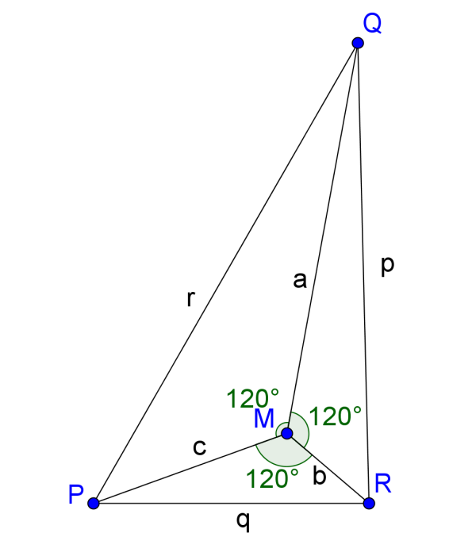 $M$ is a point inside $∆PQR$ such that

$∠PMQ=∠QMR=∠RMP=120°$

$Area of ∆PQR$

$=Area of ∆RMP+Area of ∆QMR+Area of ∆PMQ$

$\frac{1}{2}×3×4=\frac{1}{2}ab\sin{120°+\frac{1}{2}bc\sin{120°+}\frac{1}{2}ca\sin{120°}}$

$$=\frac{1}{2}ab\left(\frac{\sqrt{3}}{2}\right){+\frac{1}{2}bc\left(\frac{\sqrt{3}}{2}\right)+\frac{1}{2}ca\left(\frac{\sqrt{3}}{2}\right)}$$

$$∴ ab+bc+ca=6×\frac{4}{\sqrt{3}}=\underline{\underline{8\sqrt{3}}}$$

**(b) (i)** If $a,b,c<0$, let $x=-a,y=-b,z=-c$ then the equation becomes:

$$\left\{\begin{matrix}x^{2}+y^{2}-xy=9 \\ y^{2}+z^{2}-yz=16 \\ z^{2}+x^{2}-zx=25\end{matrix}\right.$$

which is similar to the original set of equation,

$∴ xy+yz+zx=ab+bc+ca=\underline{\underline{8\sqrt{3}}}$

**(ii)** If $a,c>0, b<0$, let $x=a,y=-b,z=c$ then the equation becomes:

$$\left\{\begin{matrix}x^{2}+y^{2}-xy=9 \\ y^{2}+z^{2}-yz=16 \\ z^{2}+x^{2}+zx=25\end{matrix}\right.$$

Put $$\left\{\begin{matrix}p^{2}=x^{2}+y^{2}-xy=x^{2}+y^{2}-2xy\cos{60°}=9 \\ q^{2}=y^{2}+z^{2}-yz=y^{2}+z^{2}-2yz\cos{60°}=16 \\ r^{2}=z^{2}+x^{2}+zx=z^{2}+x^{2}-2zx\cos{120°}=25\end{matrix}\right.$$

Since $p^{2}+q^{2}=9+16=3^{2}+4^{2}=25=5^{2}=r^{2}, p=3,q=4,r=5$

By the converse of Pythagoras Theorem, we can form $∆PQR$ right-angled at $R$.

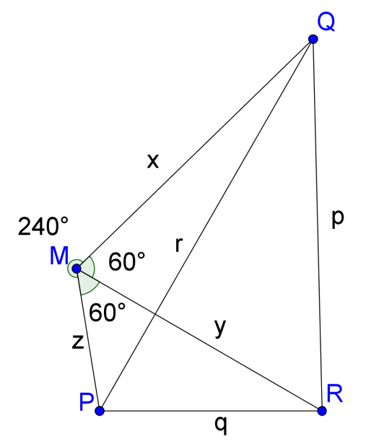 $M$ is a point outside $∆PQR$ such that

$∠PMQ=120°, ∠QMR=∠RMP=60°$

$Area of ∆PQR$

$=Area of ∆RMP+Area of ∆QMR-Area of ∆PMQ$

$\frac{1}{2}×3×4=\frac{1}{2}xy\sin{60°+\frac{1}{2}yx\sin{60°-}\frac{1}{2}zx\sin{120°}}$

$$=\frac{1}{2}xy\left(\frac{\sqrt{3}}{2}\right){+\frac{1}{2}yz\left(\frac{\sqrt{3}}{2}\right)-\frac{1}{2}zx\left(\frac{\sqrt{3}}{2}\right)}$$

$$=-\frac{1}{2}ab\left(\frac{\sqrt{3}}{2}\right){-\frac{1}{2}bc\left(\frac{\sqrt{3}}{2}\right)-\frac{1}{2}ca\left(\frac{\sqrt{3}}{2}\right)}$$

$$∴ ab+bc+ca=-6×\frac{4}{\sqrt{3}}=\underline{\underline{-8\sqrt{3}≈-13.856406460551}}$$

**(iii)** If $a<0, b,c>0$, let $x=a,y=-b,z=-c$

we can use similar method as in **(ii)**. (Readers may try.)

and can get $ab+bc+ca=\underline{\underline{-8\sqrt{3}≈-13.856406460551}}$

**(iv)** We don’t have solutions for other cases such as $a,b>0, c<0$.

**Tough readers may also try to find the values for a, b, c.**

**I include here the complete solution.**

a~~-1.00909,   b~~3.37444,   c~~-4.4185,   d~~-13.8564

a~~1.00909,   b~~-3.37444,   c~~4.4185,   d~~-13.8564

a~~-2.354,   b~~-1.02391,   c~~-3.38852,   d~~13.8564

a~~2.354,   b~~1.02391,   c~~3.38852,   d~~13.8564

**4. (Hard)** Solve for real numbers $a,b,c$:

$$\left\{\begin{aligned}a^{2}-2ab+bc-c^{2}+ca=0 \\ b^{2}-2bc+ca-b^{2}+ab=0 \\ c^{2}-2ca+ab-a^{2}+bc=0\end{aligned}\right.$$

The system is cyclic, without loss of generality, let $a≥b≥c$.

If $b=c$, then

$\left\{\begin{aligned}a^{2}-2ab+bc-c^{2}+ca=0 \\ b^{2}-2bc+ca-b^{2}+ab=0 \\ c^{2}-2ca+ab-a^{2}+bc=0\end{aligned}\right.\begin{matrix} \\ ⟹ \\ \end{matrix}\left\{\begin{aligned}a^{2}-2ab+b^{2}-b^{2}+ab=0 \\ b^{2}-2b^{2}+ab-b^{2}+ab=0 \\ b^{2}-2ba+ab-a^{2}+b^{2}=0\end{aligned}\right.\begin{matrix} \\ ⟹ \\ \end{matrix}\left\{\begin{aligned}a^{2}-ab=0 \\ 2ab-2b^{2}=0 \\ -a^{2}-ab+{2b}^{2}=0\end{aligned}\right.$

$\begin{matrix} \\ ⟹ \\ \end{matrix}\left\{\begin{aligned}a(a-b)=0 \\ 2b(a-b)=0 \\ \left(2b+a\right)(b-a)=0\end{aligned}\right.\begin{matrix} \\ ⟹ \\ \end{matrix} a=b$, ( $a,b$ may be 0)

Therefore $a=b=c$

Putting $a=b=c$ in the original system confirms the result.

Since the system is cyclic, if $a=b$, we can still give $a=b=c$ as solution.

Thus we can assume distinct values of $a,b,c$, that is, $a>b>c$.

Then we can replace $a=b+x, b=c+y, x,y>0 ∴a=c+x+y,$

$$\left\{\begin{aligned}a^{2}-2ab+bc-c^{2}+ca=0 \\ b^{2}-2bc+ca-b^{2}+ab=0 \\ c^{2}-2ca+ab-a^{2}+bc=0\end{aligned}\right.$$

$$\left\{\begin{aligned}{\left(c+x+y\right)}^{2}-2\left(c+x+y\right)\left(c+y\right)+\left(c+y\right)c-c^{2}+c\left(c+x+y\right)=0 \\ {\left(c+y\right)}^{2}-2\left(c+y\right)c+c\left(c+x+y\right)-{\left(c+y\right)}^{2}+\left(c+x+y\right)\left(c+y\right)=0 \\ c^{2}-2c\left(c+x+y\right)+\left(c+x+y\right)\left(c+y\right)-{\left(c+x+y\right)}^{2}+\left(c+y\right)c=0\end{aligned}\right.$$

$$\left\{\begin{aligned}x^{2}+c x-y^{2}=0 \\ x y+2 c x+y^{2}+c y=0 \\ -x^{2}-x y-3 c x-c y=0\end{aligned}\right.$$

$$\left\{\begin{aligned}c=-\frac{x^{2}-y^{2}}{x}, where x≠0….(1) \\ c=-\frac{x y+y^{2}}{2 x+y}, where y≠-2x….(2) \\ c=-\frac{x^{2}+x y}{3 x+y}, where y≠-3x….(3)\end{aligned}\right.$$

So if $x≠0, y≠-2x, y≠-3x$ (Note that $x,y>0$, this holds.)

$\left(1\right)=\left(2\right),$ $\frac{x^{2}-y^{2}}{x}=\frac{x y+y^{2}}{2 x+y}$ (When we put $\left(2\right)=\left(3\right)$, we get the same equation.)

$$\left(x^{2}-y^{2}\right)\left(2 x+y\right)=x\left(x y+y^{2}\right)$$

$$\left(x+y\right)\left(x-y\right)\left(2 x+y\right)=xy\left(x+y\right)$$

$$\left(x+y\right)\left(x-y\right)\left(2 x+y\right)-xy\left(x+y\right)=0$$

$$\left(x+y\right)\left[\left(x-y\right)\left(2 x+y\right)-xy\right]=0$$

$$\left(x+y\right)\left[{2x}^{2}-2xy-y^{2}\right]=0$$

(a) If $x+y=0$, then $x=-y$, but $x,y>0$. The solution is rejected.

(b) If ${2x}^{2}-2xy-y^{2}=0 or y^{2}+2xy-{2x}^{2}=0$

Using quadratic equation formula, $y=-x±\sqrt{{3x}^{2}}$

But since $x,y>0,$ we have $y=\left(\sqrt{3}-1\right)x ….(4)$

$\left(4\right)↓(1)$, $c=-\frac{x^{2}-{{\left(\sqrt{3}-1\right)}^{2}x}^{2}}{x}=\left(3-2 \sqrt{3}\right) x$

$$b=c+y=\left(3-2 \sqrt{3}\right) x+\left(\sqrt{3}-1\right)x=\left(2-\sqrt{3}\right)x$$

$$a=b+x=\left(2-\sqrt{3}\right)x+x=\left(3-\sqrt{3}\right)x$$

$\left(a,b,c\right)=\left(\left(3-\sqrt{3}\right)x,\left(2-\sqrt{3}\right)x,\left(3-2 \sqrt{3}\right) x\right)$, where $x$ is a free parameter.

**Complete solution:**

$\left(a,b,c\right)=\left(λ,λ.λ\right) or \left(\left(3-\sqrt{3}\right)μ,\left(2-\sqrt{3}\right)μ,\left(3-2 \sqrt{3}\right) μ\right)$, where $λ, μ$ are parameters.

**Yue Kwok Choy**

**11-2-2016**